CVS File Upload
Step 1: Configure Snowflake Into command prompt :
snowsql <account_name> <user_name>

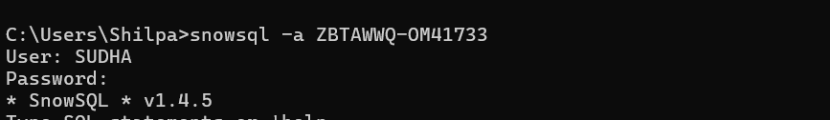
Step 2 :Create database ,Schema and Stage
create or replace database GDB;
Create or replace stage csv_file;
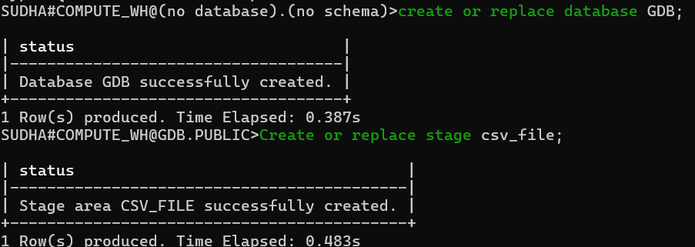
Step 3:Create or Replace table
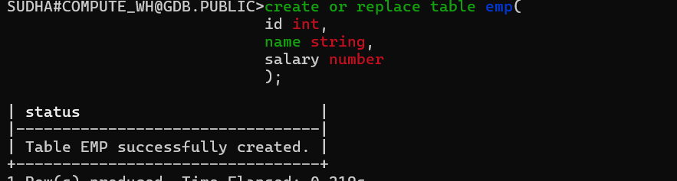
Step 4: PUT file://C:/Users/Shilpa/Documents/emp.csv @csv_file AUTO_COMPRESS = TRUE;
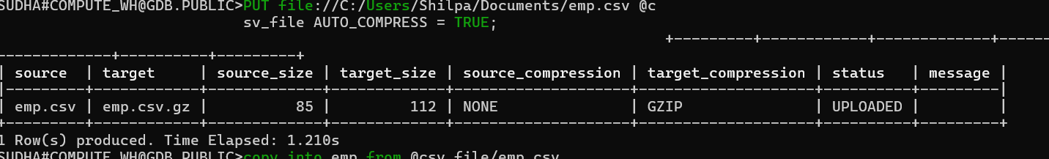
Step 5:- copy into emp from @csv_file/emp.csv file_format = (TYPE = CSV SKIP_HEADER = 1 FIELD_DELIMITER = ',');
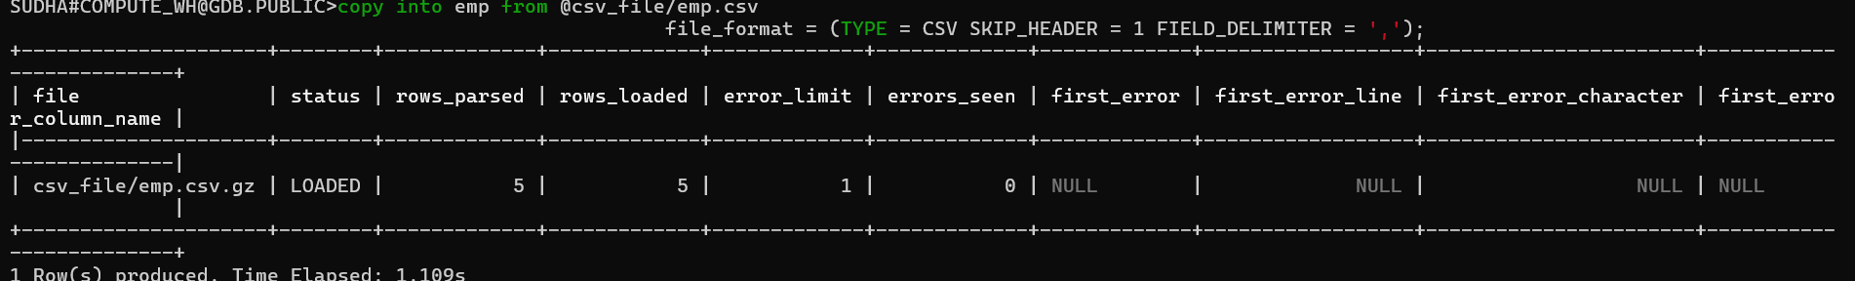
Step 6:- select * from emp;
